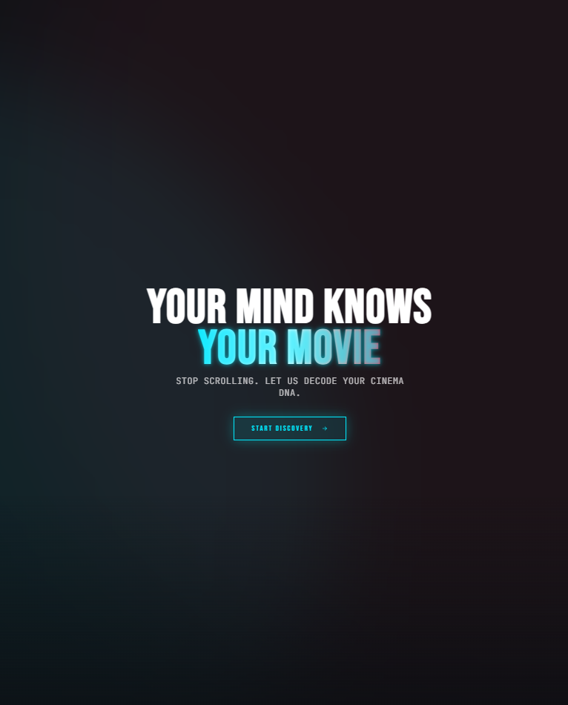

MIND FLIX
  - Intelligent Mood-Based Movie Recommendation System

ROMAN AHMAD - ABDUL MOUEED
AICT PROJECT

Description
MINDFLIX AI is a Python-based movie recommendation system that provides personalized movie suggestions based on a user’s emotional state, genre preferences, narrative expectations, and preferred emotional intensity. The system uses a lightweight rule-based recommendation engine where user responses are processed through a weighted scoring algorithm to evaluate multiple genres and identify the most suitable recommendation category. Built as a bachelor-level project, MINDFLIX AI demonstrates the practical application of recommendation system concepts, user preference modeling, decision-based scoring techniques, interactive command-line development, and modular Python programming for maintainable and scalable software design.

FEATURES
- 🎭 Mood-driven movie recommendations
- 🎬 Multi-genre recommendation support
- 🧠 Dynamic scoring-based recommendation logic
- 🔀 Randomized movie suggestions for varied results
- ✅ Input validation and controlled user interaction
- 💻 Interactive terminal-based experience
- 📦 Clean and beginner-friendly modular structure

How Recommendation Engine Works?
- Users answer a series of preference-based questions
- Each response contributes points to related movie genres
- Genres dynamically accumulate weighted scores
- The highest-scoring genre is identified
- A movie recommendation is generated from the corresponding dataset
This approach simulates the foundational logic behind modern recommendation systems while maintaining simplicity, readability, and extensibility.

Future Enhancements - Why we named it AI?

Planned future improvements include:
- Web-based graphical interface
- AI/ML-powered recommendation model (That's why the word AI)
- Expanded and dynamically updated movie database
- Personalized user profiles
- Watch history and recommendation tracking
- API-based movie information retrieval from psychology tests
- Sentiment analysis integration
- Advanced recommendation personalization
Prototype Web Version:
"MINDFLIX AI Web Prototype" (https://movie-mood-match--gamerxstorm88.replit.app?utm_source=chatgpt.com)
Current Limitations
Limited curated movie dataset
- Command-line interface only
- Fixed questionnaire structure
- Limited genre diversity
- Recommendations rely on predefined scoring logic
- No adaptive machine learning integration
- Emotional preference prediction cannot be fully accurate
Academic Purpose
This project was developed as a bachelor-level project to explore the fundamentals of recommendation systems, scoring algorithms, and interactive software design using Python.
Current Limitations
MINDFLIX AI is currently under active development and serves as a foundational prototype for future expansion into a fully featured intelligent recommendation platform.

